Безопасность детского отдыха и туризма

[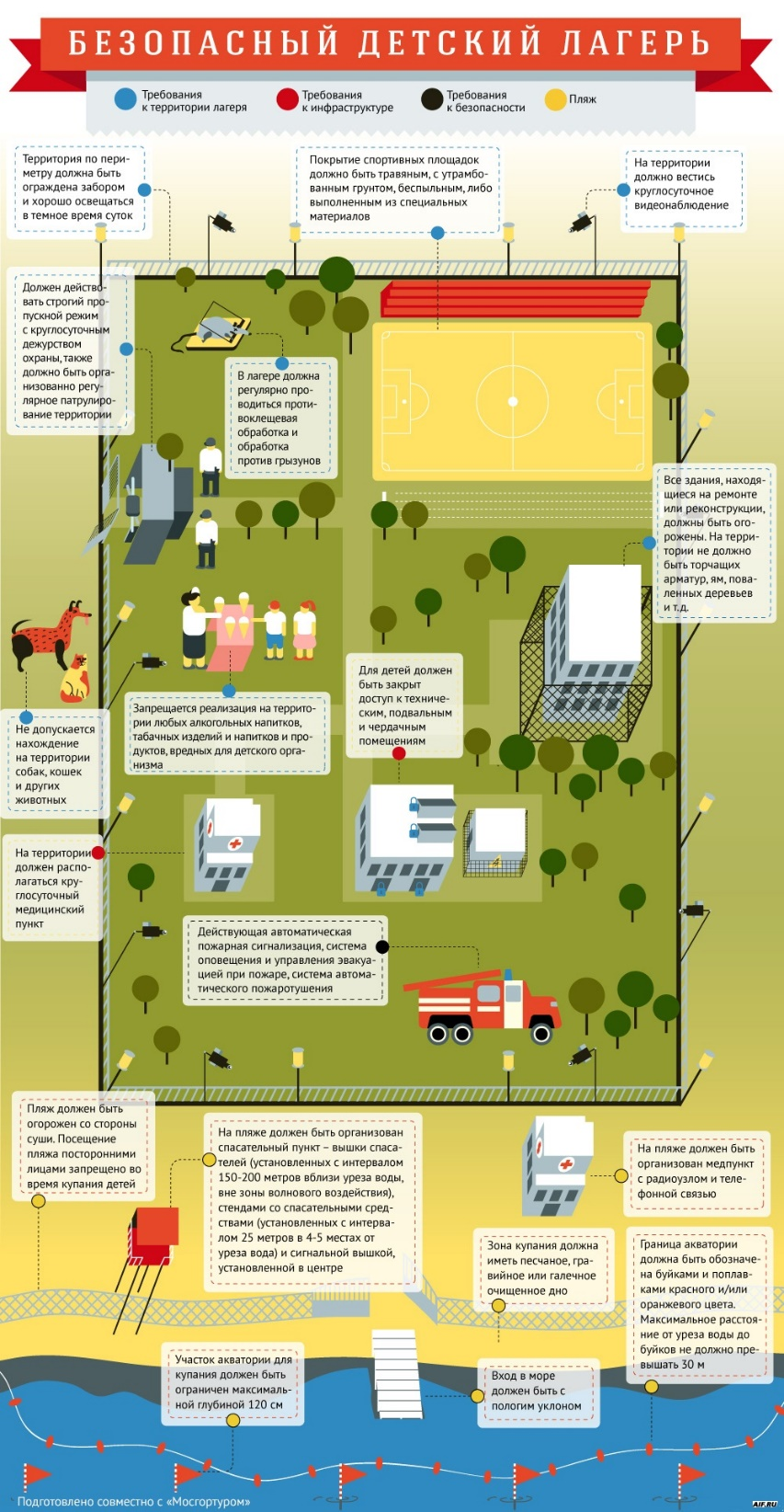](https://www.tourismsafety.ru/pic/issue/%D0%98%D0%BD%D1%84%D0%BE%D0%B3%D1%80%D0%B0%D1%84%D0%B8%D0%BA%D0%B0/%D0%BB%D0%B0%D0%B3%D0%B5%D1%80%D1%8C.jpg)

[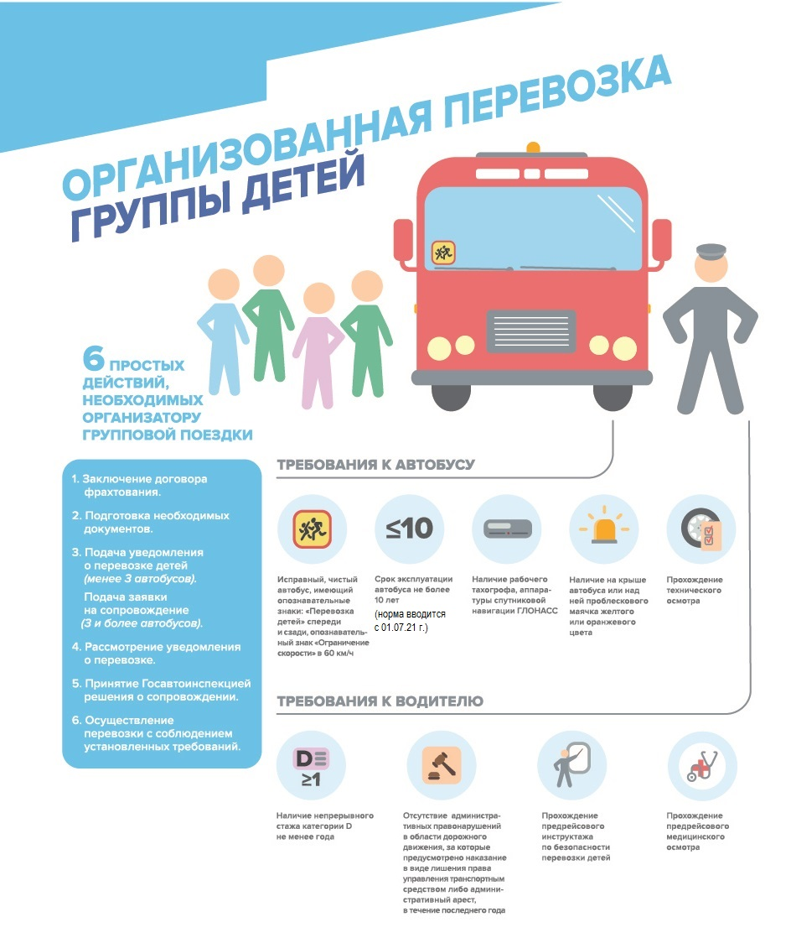](https://www.tourismsafety.ru/pic/issue/%D0%98%D0%BD%D1%84%D0%BE%D0%B3%D1%80%D0%B0%D1%84%D0%B8%D0%BA%D0%B0/%D0%BF%D0%B5%D1%80%D0%B5%D0%B2%D0%BE%D0%B7%D0%BA%D0%B02.jpg)

[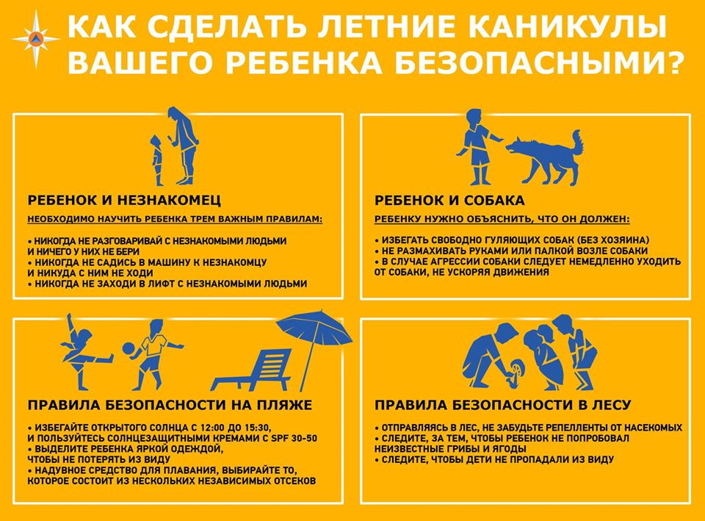](https://www.tourismsafety.ru/pic/issue/%D0%98%D0%BD%D1%84%D0%BE%D0%B3%D1%80%D0%B0%D1%84%D0%B8%D0%BA%D0%B0/%D0%B1%D0%B5%D0%B7%D0%BE%D0%BF%20%D0%BA%D0%B0%D0%BD%D0%B8%D0%BA%D1%83%D0%BB%D1%8B.jpg)

[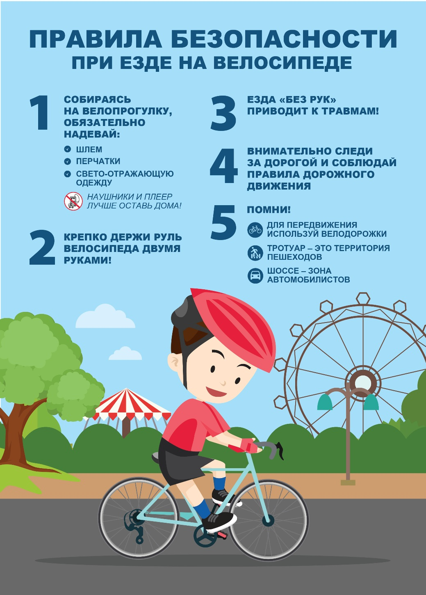](https://www.tourismsafety.ru/pic/issue/%D0%98%D0%BD%D1%84%D0%BE%D0%B3%D1%80%D0%B0%D1%84%D0%B8%D0%BA%D0%B0/Pravila_bezopasnosti_pri_ezde_na_velosipede_A4-01.jpg)

